Scottish Disability Sport Education
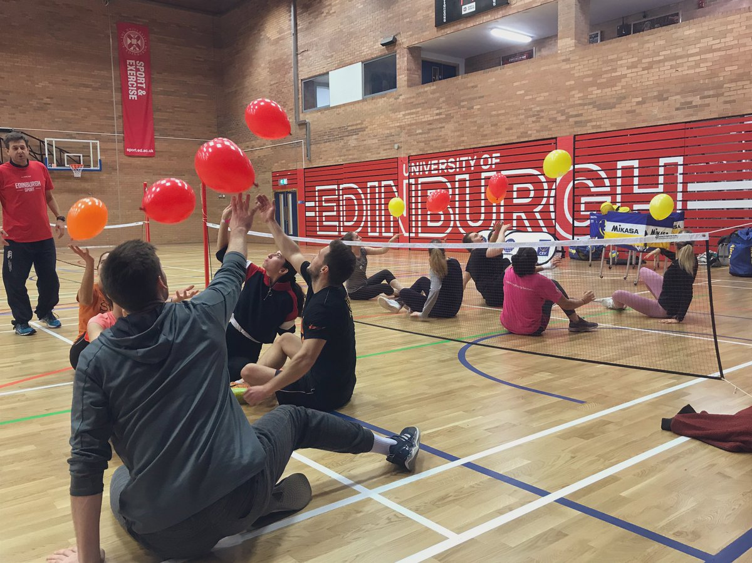
Course Organiser’s Guide

Introduction to the Guide

This organiser’s guide has been designed for those looking to book workshops with Scottish Disability Sport.

We recommend that you read through this guide before booking to understand our workshop processes and your role.

Training courses may consist of face to face theory, e-learning, or practical learning (or a combination of these environments).

To view our suite of education & learning opportunities, please visit https://www.scottishdisabilitysport.com/scottish-disability-sport-coaching/

Costs per workshop are as follows:

Workshop | Cost
Disability Inclusion Training 2 hour practical | £400
Disability Inclusion Training 3 hour theory & practical | £650
Disability Inclusion Training 6 hour SCQF accredited theory & practical | £1,200
Inclusive PE Workshop (2-hour) or Leisure Service Providers’ Workshop (2.5 hour) | £500
Boccia Leaders Award | £450
Boccia Level 1 Coach | £3,000
Boccia Level 2 Coach | £6,000

Disability Inclusion Training can accommodate a minimum of 10 and maximum of 24 learners. Boccia Level 1 and 2 courses can accommodate 12 learners. Boccia Leaders Award can accommodate a minimum of 10 and a maximum of 16 learners. If your numbers exceed the maximum, we may be able to provide additional tutors or workshops at an additional cost.

To book a workshop, tel: 0131 317 1130 or email: coaching@scottishdisabilitysport.com

We recommend booking your course at least 6 weeks prior to the course date.

Cancellation Policy
You can cancel or reschedule your workshop at no charge up until 14 days before the workshop is due to take place*.

If you cancel/reschedule within 14 days of your workshop date, you will be billed for 50% of the agreed workshop cost.

If you cancel/reschedule within 7 days of your workshop date, you will be billed for 100% of the agreed workshop cost.

*Where there is no charge to the organiser/organisation booking the workshop (i.e. where funding is in place through Scottish Disability Sport to support targeted populations), if the workshop is cancelled within 7 days it will not be rescheduled to a future date & the organiser/organisation would not be permitted to funded workshops for the remainder of that academic year.

E-learning
Most workshops require completion of our Introduction to Inclusive Practice e-learning module prior to a face-to-face practical session. Upon confirmation of your face-to-face session, you will be sent a link for your learners to register for our Introduction to Inclusive Practice e-learning module.

Once each of your learners has registered, they will receive a link to log in to Brightspace. Your learners should access Brightspace within 72 hours of receiving the link. Once this initial log-in is completed, participants can complete the module at their leisure (including being able to complete the module in more than one sitting) but will need to complete it in full before the date of their practical session as this will provide the background knowledge to enable learners to succeed in the practical session.

Each learner must register for and complete the Introduction to Inclusive Practice e-learning module individually.

Classroom session
Please note that for these sessions the organiser should be present throughout to support the tutors with any domestic arrangements/participant behaviour during the session.

All learners must register for their face-to-face/practical workshop individually and by the closing date stated by the SDS Administration Team (2 weeks prior to the workshop date).

Face-to-Face
A face-to-face classroom session may consist of practical delivery only or a mixture of theory (in place of e-learning options) and practical delivery. For practical delivery, learners should wear clothing and footwear suitable for physical activity.

For this you will need to book your chosen venue for the date and times of your workshop. It is your responsibility to book and pay for the venue and any refreshments that you want to provide.

We have created a checklist of actions for you to follow for organising an in-person session.

Upon confirming your Face-to-Face workshop ✓
Ensure your chosen facility is wheelchair accessible (some of our tutors are wheelchair users and we may use wheelchairs for practical delivery), has minimal noise disturbance and accessible toilets.
For practical delivery, an indoor, practical space with a smooth, level surface (preferably a sports hall) at least the size of a badminton court will be needed.
For theory delivery, a classroom/meeting room with enough chairs/tables for learners and a screen and projector or tv with HDMI cable are required.
15 minutes on either side of the workshop time is required for set-up/take-down.
Send the booking link (or links if you are utilising more than one delivery environment) to your learners.
Book any refreshments that you want to provide at the course.
Inform Scottish Disability Sport of your venue address.

At least two weeks before the workshop ✓
Contact the tutors to confirm timings, room name/number and access, access to any sport/disability equipment, parking and internet arrangements, and contact for the day etc.

On the Day ✓
Organiser to be present throughout to support tutors with domestic arrangements and behaviour of participants.
Ensure any refreshments ordered are there.
Set room up – are there enough seats? Is there is space for small group work?

