[INSERT CLUB NAME HERE]

Welcome Pack
www.yourwebsite.com

Welcome to [CLUB NAME]
On behalf of our Committee and coaches, we wish to extend a warm welcome to [CLUB NAME] Boccia Club. The club was formed in [formation date] and has been providing recreational and competitive opportunities for players with a disability in the sport for x years. Players of all abilities, age and experience are welcome and encouraged to join.
This document provides information relating to the following aspects of the club
- Joining the Club
- Training / Venue Information
- Competition Opportunities
- Club Contact Details
- Club Fees
- Website / Social Media
- Club Policies & Procedures

Joining the Club
Joining the Club entitles you to:
- Attend training sessions delivered by qualified coaches
- Participate and represent [INSERT CLUB NAME] in local, regional and national competitions run by Scottish Disability Sport, Scottish Boccia, Branches and other member clubs
- Be eligible for selection for the [regional squad] (dependant on impairment)
- Be eligible for selection for the Scottish national teams (dependant on impairment)
- Information and support to attend Scottish Disability Sport courses for coaching and officiating
- Attend social events organised by the Club
- Wear the [INSERT CLUB NAME] team kit for training and competition
More information on boccia in Scotland can be found by visiting www.scottishdisabilitysport.com/scottish-boccia-9/

Training / Venue Information
We aim to have a dedicated Coach and Assistant Coach at each session to support and develop our players throughout the season. All coaches and volunteers will be members of the PVG scheme.
Each player will have an opportunity to train and play practice matches at every training session. We aim to help players learn new skills, meet new friends, socialise, gain confidence and become more active.
[INSERT CLUB NAME] train once a week, (example) specific details can be found below –
Day: Tuesday
Time: 6.30pm – 8pm
Venue: Caledonia House, Edinburgh, EH12 6DQ
The club train August to June and have a season break in July.
See maps below for details on how to get to the venues and parking.
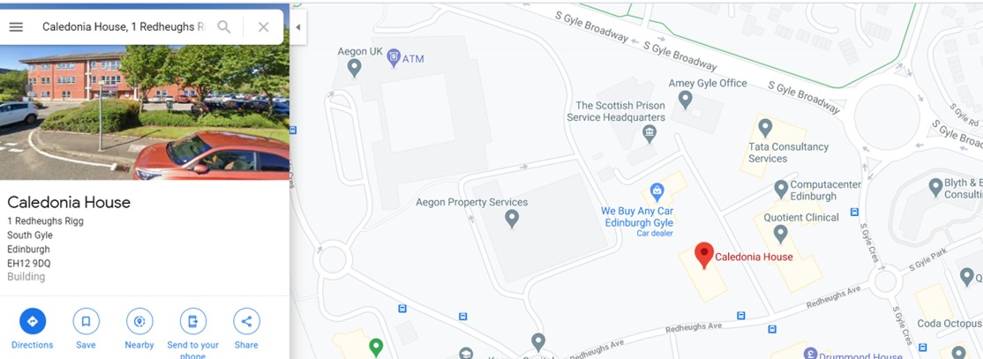
PARKING – there is adequate parking at the venue, including 4 accessible parking pays located next to the front entrance
- PUBLIC TRANSPORT – the training venue is on the route of the number X bus. The venue is approximately a 2-minute walk from the bus stop.
- VENUE ACCESSIBILITY – the training venue is fully accessible for manual and powerchair users.
- CHANGING FACILITIES – the training venue has a fully accessible changing room (including toilet) with access to movable changing bed.

Competition Opportunities
Throughout the season there are several local, regional and national competition opportunities available to all players. Entry to some of these competitions may be dependent on your impairment.
Club coaches will also provide up to date information on which competitions are available to the [INSERT CLUB NAME HERE] players and will support with the registration process where required.
The Scottish Competition Calendar can be found at www.scottishdisabilitysport.com/events/

Club Fees
Club fees are £4 per week and can be made payable to the Club Treasurer [INSERT TREASURER NAME HERE].
Fees can be paid using the following methods:
- One-off payment - A complete payment, which covers the full season’s training sessions
- Monthly Direct Debit - £x monthly standing order for [number of training sessions]
- On a weekly basis – cash paid directly to club treasurer

How to pay
There are several ways you can pay your fees:
- Cash (to the Club Treasurer)
- Cheque – made payable to [INSERT CLUB NAME] (to the Club Treasurer)
- Monthly Direct Debit (see Club Treasurer for details on how this can be set up)

Website / Social Media
[INSERT CLUB NAME] will use the club website and social media platforms to promote the club / sport, celebrate success, share information, raise awareness etc.
If you don’t want your information / picture shared via the website / social media please let the Website / Social Media Co-ordinator know ASAP. More information can be found by visiting the clubs Data Protection / Privacy policy – please speak to the club committee to obtain a copy of this.
Please find the following details:
Website address – [INSERT CLUB WEBSITE ADDRESS HERE]
Facebook – [INSERT CLUB FACEBOK HANDLE HERE]
Twitter – [INSERT CLUB TWITTER HANDLE HERE]
Instagram - [INSERT CLUB INSTAGRAM HANDLE HERE]

Club Policies & Procedures
All [INSERT CLUB NAME HERE] policies and procedures can be found on the club’s website. Alternatively, the club committee will have a copy of all documents for players information.

Child Protection
[INSERT CLUB NAME HERE] is committed to child protection and the welfare of children, young people and vulnerable adults in our sport. Everyone at our club is entitled to protection from harm and take part in boccia in a safe and enjoyable environment. To obtain a copy of the club’s Safeguarding Policy please speak to the committee or download here.
[Insert Club Name here] child protection and welfare officer is [Name person] and can be contacted on [Contact details]. If you have any concerns for yourself or others contact them as soon as possible.

Code of Conduct
All players, coaches, volunteers, and parents will be required to complete a club code of conduct which outlines expectations during while representing the club during training and competition. This document aligns with the club’s values of inclusion, respect and sportsmanship and are central to the club. Please ask the club committee for a copy of the code of conduct or download here.

Opportunity to Learn
Players and parents will be given the opportunity to access coaching and officiating qualifications provided by Scottish Disability Sport. [INSERT CLUB NAME] will support anyone interested in these opportunities.
The club is also committed to supporting new and existing coaches & volunteers to develop and will encourage continued development via signposting and access to further coaching qualifications, first aid courses etc.

Club Contact Details
[INSERT CLUB NAME HERE] Committee and coach contact details can be found below:
Role / Responsibility | Name | Contact Number | Contact Email
Chairperson | Joe Bloggs | 0770 xxx xxxx | Joe.Bloggs@boccia .com
Secretary
Treasurer
Safeguarding Officer
Athlete Representative
Website / Social Media Rep
Lead Coach
Coach

