Safeguarding Children, Young People and Adults at Risk Policies and Procedures

Safeguarding Officer:
Number:
Email:

Contacts Page
Page
 |  | Foreword and Governance
4 | 1 | Introduction
4 | 2 | Definitions of Child & Adult at Risk
5 | 3 | Glossary of Terms
5 | 4 | Promoting Good Practice
6 | 5 | Key [CLUB NAME] Contacts for the Protection of Children, Young People & Adults at Risk
7 | 6 | Recognising and Reporting Suspected or Actual Abuse
13 | 7 | Types of Abuse
13 | 8 | Physical Abuse
14 | 9 | Neglect
14 | 10 | Sexual Abuse
16 | 11 | Emotional Abuse
16 | 12 | Protection of Protected Groups (Scotland) Act 2007 (PVG Scheme)
17 |  | Guidance on Changing Room Management / Chaperoning
18 | 13 | Policy for Use of Photographic and Video Equipment
18 | 14 | Policy for Using Children, Young People & Adults at Risk in Publications & on the Internet
19 | 15 | Consent Form when Using Athletes in Publications & on the Internet
20 |  | Appendix A: Child/Adult at Risk Protection Procedures (for staff, coaches and volunteers)
21 |  | Appendix B: Child/Adult at Risk Protection Procedures (for participants)
22 |  | Appendix C: SHANARRI Wheel

Foreword
[CLUB NAME] has produced a set of policies and procedures that cover equality and the safeguarding of children, young people and adults at risk.

INTRODUCTION

[CLUB NAME] – Providing Safe and Secure Environments
Sport can have a very positive influence on the life of an individual with a disability. Sport can offer traditionally excluded communities the opportunity to participate, compete and achieve success in stimulating environments. Sport is fun and enjoyable and through sport essential life skills such as independence, social interaction, improved self-esteem, teamwork, leadership and confidence can be developed.
This process will only be successful and positive if the well-being of the participants is the number one priority. Those in responsible positions as volunteers, leaders or coaches must adopt practices and follow procedures that are supportive, empowering, protective and motivate the participants to give their best.
[CLUB NAME] is fully committed to safeguarding the welfare of, and providing safe and secure environments for, all children, athletes, players, coaches, volunteers, officials and spectators to enjoy sport.

DEFINITIONS OF CHILD AND ADULT AT RISK

Child
The [CLUB NAME] Safeguarding Policy for Children takes into consideration the National Guidance for Child Protection in Scotland 2014, the principles of “getting it right for every child” (GIRFEC) and the principles of the SHANARRI Wheel (see Appendix A). [CLUB NAME] recognises our responsibility to promote safe practice and to protect children and young people from harm, poor practice, exploitation and abuse. [CLUB NAME] is fully committed to a rights-based approach and therefore recognise and implement the general principles of the UN Convention on the Rights of the Child (UNCRC).
Staff and volunteers will work together to embrace difference and diversity and respect the rights of children and young people.
Definition – “Child”
The Children and Young People (Scotland) Act 2014 – a child is defined as anyone who has not reached the age of 18.
[CLUB NAME] recognise anyone under 18 as a child. For the purposes of this policy, “children”, “child”, and “young person” refer to persons up to the age of 18.

Adult at Risk
Definition – “Adult”
A person aged 16 years or above, however anyone aged under 18 years old will be covered under “child” as well.
Definition of an “Adult at Risk”
The Adult Support and Protection (Scotland) Act 2007 defines an adult at risk as someone who can’t safeguard themselves, their wellbeing, their property or their rights; is at risk of harm and is experiencing:
- A disability
- A mental disorder
- Illness
- Physical or mental infirmity
An adult is at risk of harm if:
- The conduct of another person is causing (or likely to be causing) the adult to be harmed
- The adult themselves engages in conduct that is causing (or likely to cause) self-harm.
The term “adult at risk” replaces the previously used terms of “adult at risk” and “vulnerable adult”. A disabled/older person is not necessarily an adult at risk, and an adult at risk may not have an impairment.
The vulnerability of an adult at risk is related to how able they are to make and exercise their own informed choices free from duress, pressure or undue influence of any sort, and to protect themselves from abuse, neglect and exploitation. It is not a given that by being in one of the above categories an adult is automatically considered to be at risk. This policy shall only take effect when an adult at risk is participating in any action covered under the jurisdiction of [CLUB NAME].

GLOSSARY OF TERMS
[CLUB NAME]
Child | Scots Law dictates this to be a person under 16. For the purposes of [CLUB NAME] Policies – “child” will cover ALL athletes under your care or supervision whatever their ability, disability, age, gender, sexual identity or ethnicity, including adults at risk.
Youth | Generally referred to meaning under 18 by other agencies, in this case to be taken as for “child”.
Athlete or Player | A person joining training in care of coach/sports leader.
Coach | Specifically employed or volunteering as a coach with direct responsibility for athletes or players.
Sports Leader | To be applied to all helpers, teachers and coaches, whether qualified, unqualified, paid or voluntary.
Child Protection | Our “duty of care” to all within our sport and all that this involves in terms of training, communication and process development.
Disclosure | The term to be applied to all reporting and allegations of concern or abuse.
Regular | As a guideline, regular contact is considered to be more than three times per year. However, we would recommend that all staff needs are planned for and added into the recruitment process.

NOTE:
Safeguarding in Sport is a partnership between CHILDREN 1ST and sportscotland. Like [CLUB NAME], these organisations believe that all children and young people have the right to be protected from abuse and harm. Safeguarding in Sport supports sporting organisations to keep children and young people safe.
mailto:safeguardinginsport@childen1st.org.uk

PROMOTING GOOD PRACTICE FOR WORKING WITH CHILDREN, YOUNG PEOPLE AND ADULTS AT RISK
Although policies and procedures for the protection of children, young people and adults at risk are necessary, it is important to put them into perspective and not be intimidated by the information. The best way to comply with new legislation and procedures is to use common sense. [CLUB NAME] supports and requires the following good practice by members when in contact with children, young people and adults at risk. By demonstrating exemplary behaviour all paid and voluntary personnel can protect themselves from false allegations whilst securing a safe and enjoyable environment for all those involved.
When working with children, young people and adults at risk these good practice guidelines are recommended to minimise the risk of abuse:
- Sport should be fun, enjoyable and promote fair play.
- Always work in an open environment, e.g. avoid private, unobserved situations and secrets.
- Treat all children, young people and adults at risk with equal respect and dignity.
- Put the well-being of all children, young people and adults at risk first before winning or achieving performance goals.
- Be an excellent role model including no smoking or drinking alcohol in the company of children, young people and adults at risk.
- Offer enthusiastic and constructive feedback rather than negative criticism.
- Ensure if any form of manual or physical support is required for a child, young person or adult at risk, it is provided openly, the athlete is informed of what is being done and their consent is obtained.
- Deliver educational instruction first verbally; secondly by demonstration; and thirdly, only if necessary, with hands-on – which must be accompanied by telling the child, young person or adult at risk where you are putting your hands and why this is necessary and obtaining their consent.
- Involve parents, guardians and carers wherever possible.
- Build balanced relationships based on mutual respect that empower athletes to share in the decision-making process.
- Maintain a professional relationship with athletes, e.g. it is not appropriate to have an intimate relationship with a child, young person or adult at risk, or to share a room with them unless the specific care needs of the individual athlete dictates otherwise.
- Recognise the developmental needs and capacity of children, young people or adults at risk and avoid excessive training or competition and either pushing them against their will or putting undue pressure on them.
- Be aware of any pre-existing medical conditions, medicines being taken by participants or existing injuries and treatment required.
- Keep a written record of any injury that occurs, along with the details of any treatment given.
- Where possible, ensure access to medical advice and/or assistance is available.

[CLUB NAME] KEY CONTACTS FOR THE PROTECTION OF CHILDREN, YOUNG PEOPLE AND ADULTS AT RISK
Everyone involved with [CLUB NAME] has a responsibility to ensure that all children, young people and adults at risk involved in programmes and activities do so within a safe and secure environment.
[CLUB NAME] has identified specific individuals who have particular roles to help ensure that appropriate policies and procedures are in place to prevent and where necessary deal with any concerns or incidents relating to the protection of children, young people or adults at risk.
- If you have any concerns or would like to discuss a specific issue relating to the protection of children, young people or adults at risk please contact:
Safeguarding Officer for the Protection of Children, Young People and Adults at Risk –.
The Safeguarding Officer has the responsibility to liaise with appropriate personnel and organisations to ensure the most appropriate response to any incidents or concerns. If you have any concerns or would like to report a specific incident about the protection of children, young people or adults at risk please contact [SAFEGUARDING OFFICER NAME] to discuss the issue in private and ensure confidentiality.
In order to access Scottish Disability Insurance, the Club must have appointed a named Safeguarding Officer who has undertaken relevant Safeguarding Officer training.
- If you have any question or queries in relation to the policies and procedures of [CLUB NAME] please contact one of the following individuals:
OVERALL RESPONSIBILITY for ensuring the protection of children, young people and adults at risk:
The Chair has the overall responsibility of ensuring that the protection of children, young people and adults at risk is a key target of the organisation and that the appropriate work is carried out to ensure this is implemented. The Chair operates at a strategic level with other organisations to ensure that appropriate policies are being developed and implemented within the organisation.
- Board level responsibility for the Protection of Children, Young People and Adults at Risk
[NAME] is responsible for overseeing the introduction and approval of policies and procedures for [CLUB NAME] and ensuring that the Board operates in an equitable manner.

RECOGNISING AND REPORTING SUSPECTED OR ACTUAL ABUSE
[CLUB NAME] Anti-Bullying Policy
Overview
[CLUB NAME] believes that every individual has the right to experience sport in a safe environment free from abuse and bullying.
This policy takes into consideration the Scottish Government funded anti-bullying policy: respect me, Scotland’s Anti-Bullying Service, managed in partnership with SAMH (Scottish Association for Mental Health), and LGBT Youth Scotland. For more information go to:
https://beta.gov.scot/publications/respect-national-approach-anti-bullying-scotlands-children-young-people/pages/2/

Statement of Intent
Everyone has the right to participate in sport and leisure activities in an environment and culture where they feel respected, encouraged and safe from harm. Bullying is an issue which can arise within the sports environment and can breach these rights. As such, this policy has been implemented because [CLUB NAME] is committed to providing a caring, friendly and safe environment for all so they can participate in sport in a relaxed and secure atmosphere. Bullying of any kind is unacceptable and will not be tolerated. If bullying does occur, we want individuals to know who to tell in [CLUB NAME] and know that incidents will be dealt with promptly, effectively and compassionately. This means that anyone who knows that bullying is happening understands why they need to tell the nominated [CLUB NAME] representative at the time or report the matter to the [CLUB NAME] Chair.

Objectives of This Policy
This policy is to make the approach taken by [CLUB NAME] towards bullying clear so:
- Everyone has an understanding of what bullying is;
- Everyone knows what the [CLUB NAME] policy is on bullying, and knows what to do if it arises and/or is reported;
- Everyone is assured that [CLUB NAME] takes bullying seriously and has an understanding that they will be supported when bullying is reported. All complaints will be dealt with seriously, promptly and with confidentiality; and
- It is clear to all that [CLUB NAME] will not tolerate bullying.

What Do We Mean By Environments?
For the purpose of this policy an environment refers to the conditions (both physical and rules) set for controlling any sporting activity taking place. In this policy and context, an [CLUB NAME] controlled environment means any occasion where the conditions are set and controlled by [CLUB NAME] and, therefore, it is within the control of [CLUB NAME] to change the conditions if necessary. A non-[CLUB NAME] controlled environment refers to any occasion where [CLUB NAME] may be represented or have individual [CLUB NAME] members, athletes, coaches or volunteers involved but the conditions are set by a third party, e.g. a Branch or partner organisation.

What Are Harassment and Bullying?
Harassment
Harassment is unwanted or offensive conduct related to one of the following grounds (which are known as “protected characteristics”):
- Sex;
- Sexual orientation;
- Marriage and civil partnership;
- Pregnancy and maternity;
- Age;
- Gender reassignment;
- Race
- Disability;
- Religion or belief;
where the conduct affects an individual’s dignity or creates an intimidating, hostile, degrading, humiliating or offensive environment. This can include unwelcome physical, verbal or non-verbal conduct. Such behaviour is unacceptable:
- Where it is unwanted, unreasonable or offensive to the recipient;
- Where it is used as the basis for an employment decision;
- Where it creates an intimidating, hostile, degrading, humiliating or offensive working environment.
Harassment often (but not exclusively) targets a protected characteristic of the victim. A person may also be harassed because of their relationship with someone else (through association) or because of others’ perception of them.
Bullying
Bullying can be defined as aggressive, offensive, abusive, intimidating, malicious or insulting behaviour, which makes (or intends to make) the recipient feel hurt, upset, threatened, humiliated or vulnerable, undermines their self-confidence and causes them to suffer stress. Bullying can arise from a one-off incident or may happen repeatedly. Some examples of bullying are:
- Emotional – being unfriendly, excluding, tormenting (e.g. threatening gestures);
- Physical – pushing, kicking, hitting, punching or any use of violence;
- Prejudice-based bullying;
- Verbal – name-calling, sarcasm, spreading rumours, teasing; and/or
- Cyber – all areas of social media misuse, including abuse by text messaging and calls, misuse of camera and video technologies.
Awareness
[CLUB NAME] hopes to avoid incidents of bullying and has taken steps to outline in its code of conduct, and policies what is acceptable and proper behaviour. All member Branches, staff, athletes, coaches and volunteers are given the opportunity to review these documents and agree to abide by the conduct set out in these documents. This includes this Anti-Bullying Policy. All these documents are available on the [CLUB NAME] website.
In an [CLUB NAME] controlled environment, [CLUB NAME] will appoint an individual as the named contact (Safeguarding Officer) for reporting all incidents of welfare concern, including bullying. Where appropriate, this individual will attempt to manage and resolve the situation at the time.
Should it not be possible to report the concern to the Safeguarding Officer at the time any concerns can be reported directly to the [CLUB NAME] Chair. Regardless of when the situation is resolved, all concerns will be reported to the [CLUB NAME] Chair for the purposes of maintaining a record.
If anyone has a concern about welfare, including bullying, then please report this to the [CLUB NAME] Safeguarding Officer.

Procedure in an [CLUB NAME] Controlled Environment
As with all matters relating to welfare and conduct in an [CLUB NAME] controlled environment, the [CLUB NAME] Procedure for Complaints, Concerns, Grievances, Disciplinary and Appeals can be found in detail within the [CLUB NAME] Safeguarding Children, Young People and Adults at Risk Policies and Procedures documents. This means the handling of any bullying incident shall be dealt with as follows:
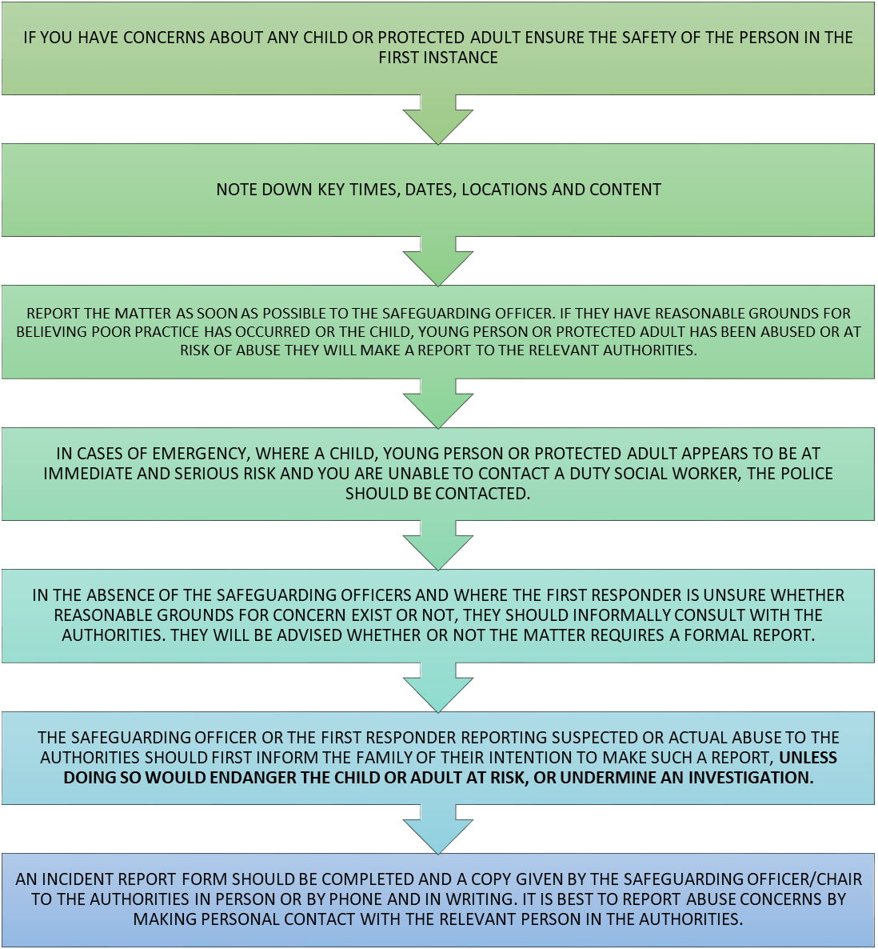
In cases where welfare concerns, including bullying, involve individuals under 18 years of age, parents or guardians will be made aware of the incident and involved in the investigations and disciplinary process. Also, as outlined in the [CLUB NAME] Procedure for Complaints, Concerns, Grievances, Disciplinary and Appeals, if the concerns are sufficient and it is deemed appropriate, Police Scotland will also be consulted and involved.

Anti-bullying Procedure
As with all matters relating to welfare and conduct, the [CLUB NAME] Procedure for Complaints, Concerns, Grievances, Disciplinary and Appeals shall be followed. This means the handling of any bullying incident shall be dealt with as follows:
- Accessing a confidential contact – for non-[CLUB NAME] controlled environments, there will not be a [CLUB NAME] nominated individual so please contact [CLUB NAME] Chair/Safeguarding Officer. Depending on the circumstances, [CLUB NAME] may nominate an individual closer to you as a confidential contact for you to speak to and to help resolve the situation;
- Informal stage, i.e. this can be a series of conversations, including mediation, to address behavioural concerns with the relevant parties. This can be facilitated by [CLUB NAME] or by the body responsible for the occasion, depending on what is deemed appropriate by the [CLUB NAME] Chair/Safeguarding Officer; and
- Formal stage, i.e. an investigation, managed by the [CLUB NAME] Chair, to report on findings and agree the actions that need to be taken to address any behavioural concerns and reduce the chance of repeated incidents. In non-[CLUB NAME] controlled environments, actions available to [CLUB NAME] relating to the environment will be limited.
In cases where bullying involves individuals under 18 years of age, parents or guardians will be made aware of the incident and involved in the investigation and disciplinary process and, as outlined in the [CLUB NAME] Procedures for Complaints, Concerns, Grievances, Disciplinary and Appeals, if the concerns are sufficient and it is deemed appropriate, Police Scotland will also be consulted and involved.

Taking Action
The [CLUB NAME] Procedure for Complaints, Concerns, Grievances, Disciplinary and Appeals outlines the process to be followed and type of action available. When deemed appropriate by the nominated [CLUB NAME] representative, action will be taken to address matters in the following order:
- Preventative measures to reduce the risk of that individual suffering from any further bullying (these may be limited in non-[CLUB NAME] controlled environments); then
- Action to address the conduct of the individual(s) displaying bullying behaviour.
Preventative Measures
Preventative measures shall be viewed with regards to:
- Immediate changes – these can include a change of process, room sharing for a squad session, etc.; and
- Long-term changes – taking note of any incidents and, where practicable, putting in place plans to reduce the risk of future bullying at the club, event or squad session.
Action
When addressing the conduct of the individual(s) displaying bullying behaviour, the following is a non-exhaustive list providing examples of actions that could be taken to help prevent, or react to, incidents of bullying:
- Holding a reconciliation meeting between parties at an appropriate time;
- For those under the age of 18, the parent of the child displaying bullying behaviour, or the bullied individual can be asked to attend events, club or squad sessions, if they are able to do so, and if appropriate;
- Supporting those displaying bullying behaviour to change their behaviour;
- Holding a session with the squad or event attendees to review what is and is not appropriate behaviour (only applicable in an [CLUB NAME] controlled environment);
- Working to improve procedures and processes for managing/responding to concerns;
- Further/increased monitoring to ensure repeated bullying behaviour does not take place;
- The individual(s) displaying bullying behaviour receives a verbal warning;
- The individual(s) displaying bullying behaviour receives a written warning;
- The individual(s) displaying bullying behaviour receives a final written warning;
- The individual(s) displaying bullying behaviour is withdrawn from the club, event or squad session;
- The individual(s) displaying bullying behaviour is suspended from taking part in [CLUB NAME] events or squad sessions for a period.
When deciding on what action to take, those involved in the decision will be informed if any individual displaying bullying behaviour in this incident has had previous incidents relating to their conduct, including the nature and action taken at the time, to help determine what action should be taken on this occasion.
Where appropriate, coaches, volunteers or club officials involved with any of the individuals, will be made aware of any incidents and action taken to help with the monitoring and management of any behaviour.

Written Records
For matters where the procedure does not proceed beyond the informal stage, the following summary information will be collected by the [CLUB NAME] Chair from the [CLUB NAME] Safeguarding Officer:
- Summary of incident, including the names of those involved;
- Summary of the informal investigation process to corroborate information; and
- Summary of what action, changes and which people/bodies were informed and when, if any.
For matters advancing to the formal stage, more detailed information on the incident and subsequent action taken will be captured in the report produced by the investigator and the minutes from the group tasked with reviewing the evidence and agreeing on the action to be taken.
Any information collected from the informal or formal stage will be kept confidential, stored securely and indefinitely, only to be used when the individual(s) involved have been deemed to have been displaying undesirable conduct on a future occasion or as part of a future police investigation.

Further Advice
For further advice or to discuss any concerns please contact the [CLUB NAME] Safeguarding Officer.

[CLUB NAME] Incident Record Form
PRIVATE & CONFIDENTIAL
Name of Club: ………………………………………………………
This form is to be used to record an occurrence or allegation of abuse. Please complete all relevant sections carefully and accurately.
Remember to maintain confidentiality. Do not discuss the incident with anyone, other than the Safeguarding Officer or the appropriate external agencies.
Your name:
Your position:
Club members’ name:
Club members’ address:
Parent/guardian name (if appropriate):
Parent/guardian address (if appropriate):
Club members’ date of birth:
Date and time of alleged incident:
Record exactly what the member said and what you said/asked to clarify the situation. Remember, do not influence or lead the member’s account – record actual details. (Use a separate sheet and attach if necessary.)
Your observations, who you spoke to and when:
Action taken to date and when:

TYPES OF ABUSE
National Policy and Guidance for statutory agencies in the UK generally refer to four categories of abuse. These are:
- Physical abuse;
- Neglect;
- Sexual abuse;
- Emotional abuse.
In addition to the categories as listed above, [CLUB NAME] also recognises that discrimination and bullying can have severe and adverse effects on children, young people or adults at risk. In its commitment to protect children, young people or adults at risk from all potentially harmful behaviour, [CLUB NAME] will deal with any discrimination and bullying under these procedures.
Recognising abuse is not easy and it is not [CLUB NAME]’s responsibility to decide whether a person has been abused. It is their responsibility to pass on any concerns and for the police and social work services to investigate the concerns.
The descriptions and lists below are not definitive or exhaustive. They are designed to help [CLUB NAME] to be more alert to the signs of possible abuse.
[CLUB NAME] should remember that in relation to abuse, an assessment of reasonableness should always be applied. This refers to any possible allegations as well as considering what action to take when someone has concerns. For example: if, to a reasonable person, a child requires medical attention and no-one secures it within a reasonable time, then an allegation of neglect may be valid.

PHYSICAL ABUSE
Physical abuse may involve the actual or attempted physical injury to a person. Physical abuse may also be caused when a parent or carer feigns the symptoms of, or deliberately causes, ill health to a person they are looking after.
Physical abuse may be a deliberate act or may result from a failure of somebody to do something, or from a failure by someone to fulfil his or her duty to protect a person.
- Physical Injury in Sport
This may include bodily harm caused by a lack of care, attention or knowledge that may be caused by:
- Over training or dangerous training of athletes;
- Over-playing an athlete;
- Failure to do a risk assessment of physical conditions, physical limits, or pre-existing medical conditions;
- Administering, condoning or failure to intervene in drug use.

- Signs of Possible Physical Abuse
Most children will sustain cuts and bruises throughout childhood. These are likely to occur in bony parts of the body like elbows, shins and knees. In most cases, injuries or bruising will be genuinely accidental. An important indicator of physical abuse is where the bruises or injuries are unexplained or the explanation does not fit the injury or the injury appears on a part of the body where accidental injuries are unlikely. The age/maturity of the individual must also be considered. Signs of possible physical abuse include:
- Unexplained injuries or burns, particularly if they are recurrent;
- Improbable explanations or excuses given to explain injuries;
- Refusal to discuss injuries;
- Fear of parents being approached for an explanation;
- Fear of returning home;
- Untreated injuries, or delays in reporting them or in seeking medical attention;
- Excessive physical punishment to themselves;
- Arms and legs kept covered in hot weather;
- Avoidance of activity where legs, arms, etc. will be visible,
- Aggression towards others/acceptance of physical aggression as a normal way of life;
- Running away.
When considering the possibility of non-accidental injury, it is important to remember that injuries may have occurred for other reasons, e.g. skin disorders, rare bone diseases.

NEGLECT
Neglect is the persistent failure to meet the basic needs of an individual. It may involve a parent or carer failing to provide adequate food, shelter, warmth, clothing or cleanliness. It may also include leaving a child or adult at risk at home unattended, exposure to conditions where they may be caused unnecessary suffering or injury, or the failure to ensure that appropriate medical care or treatment is received.
- Neglect in Sport
This could include the lack of care, guidance, supervision or protection that may be caused by:
- Exposure to unnecessary cold or heat;
- Exposure to unhygienic conditions, lack of food, water or medical care;
- Non-intervention in bullying or taunting;
- Training for too long without sufficient re-hydration and rest breaks;
- Leaving children or young people unsupervised for any period ;
- Inability to implement sufficient warm-up before strenuous activity – increasing risk of injury.
Neglect, as well as being the result of a deliberate act, can also be caused through the omission or the failure to act or protect.
- Signs of Possible Physical Neglect
- Constant hunger;
- Poor personal hygiene;
- Constant tiredness;
- Poor state of clothing;
- Frequent lateness (that sometimes includes explanations of the individual having to get him/herself up in the morning, fed and out to school/training);
- Untreated medical problems;
- Low self-esteem;
- Poor peer relationships;
- Stealing.

SEXUAL ABUSE
Sexual abuse involves forcing or enticing a child, young person or adult at risk to take part in sexual activities whether they are aware of, or consent to, what is happening. The activities may involve physical contact, including penetrative or non-penetrative sexual acts. The activities may also involve non-contact activities such as forcing children or young people to look at pornographic material or be involved in the production of pornographic material, to watch sexual activities, or encouraging them to behave in sexually inappropriate ways.
Child prostitution is sexual abuse. Many young people believe that they have chosen to prostitute and that they are in control of what they do. The reality is that many are in great danger and are being exploited by adults.
Boys and girls can be sexually abused by males and/or females, including persons to whom they are not related and by other young people. This includes people from all walks of life. Many adults who sexually abuse children do have ongoing “normal” adult sexual relationships.
- Sexual Abuse in Sport
This could include contact and non-contact activities and may be caused by:
- Exposure to sexually explicit inappropriate language, jokes or pornographic material;
- Inappropriate touching;
- Engaging in any sexual activity or relationship;
- Creating opportunities to inappropriately observe the bodies of children and young people.
Not all children, young people or adults at risk are able to tell that they have been sexually abused. Either they may not be able to tell or they may not know that they have been victims of abuse. Abusive adults who are skilled in grooming children will behave in such a way that the child is unaware that they are being set up for abuse or, in some cases, are being abused.
Changes in an individual’s behaviour may be the signal that something has happened. It is important to note, however, that there may be no physical or behavioural signs to suggest that a child, young person or adult at risk has been sexually abused.
- Signs of Possible Sexual Abuse
Behavioural signs
- Lack of trust in adults;
- Over-familiarity with adults;
- Fear of a particular adult, or adults;
- Developmental regression (begins to behave like a much younger child);
- Social isolation – withdrawn or introverted (especially if this is a change from normal);
- Running away from home;
- Sudden school problems, e.g. falling standards, truancy;
- Reluctance or refusal to participate in normal coaching/training/games, or to change clothes in the company of others;
- Low self-esteem;
- Drug, alcohol or substance misuse;
- Fear of bathrooms, showers, closed doors, etc.;
- Fear of medical examinations;
- Poor peer relationships;
- Stealing;
- Irrational fears;
- Eating disorders;
- Psychosomatic factors, e.g. recurrent pain;
- Sexual promiscuity;
- Over-sexualised behaviour;
- Display of sexual knowledge beyond the child’s age
- Unusual interest in the genitals of adults, children or animals;
- Sexually explicit drawings;
- Compulsive masturbation.
Physical or medical signs
- Bruises, scratches, bite marks to the thighs or genital areas;
- Anxiety, depression;
- Eating disorder, e.g. anorexia nervosa or bulimia;
- Discomfort/difficulty in walking or sitting;
- Pregnancy – particularly when reluctant to name the father;
- Pain on passing urine, recurring urinary tract problem, vaginal infections or genital damage;
- Venereal disease/sexually transmitted diseases;
- Soiling or wetting in children who have been trained;
- Itchiness, soreness, discharge, unexplained bleeding from the rectum, vagina or penis;
- Stained underwear;
- Unusual genital odour;
- Self-mutilation, suicide attempts.

EMOTIONAL ABUSE
Emotional abuse is the persistent emotional ill-treatment of a child, young person or adult at risk such as to cause severe and adverse effects on their emotional development. It may involve conveying that they are worthless, unloved, useless, inadequate or not valued.
It may feature age or developmentally inappropriate expectations being imposed. It may also involve causing the individual to feel frequently frightened or in danger, such as when they have to live in a home where there is domestic violence or aggression. It may involve corruption or exploitation.
- Emotional Abuse in Sport
This may include the persistent failure to show respect, build self-esteem and confidence that may be caused by:
- Exposure to humiliating or aggressive behaviour or tone;
- Demeaning efforts by continuous negative feedback;
- Failure to intervene where self-confidence and worth are being challenged or undermined.
- Discrimination based on race, religion, gender, gender reassignment, sexual orientation, age, pregnancy/maternity, disability, or marriage/civil partnership.
- Signs of Possible Emotional Abuse
- Low self-esteem;
- Continual self-deprecation/criticism (“I’m hopeless”, “I’m useless”, etc.);
- Sudden speech disorder;
- Significant decline in concentration;
- “Neurotic” behaviour, e.g. rocking;
- Self-mutilation, suicide attempts;
- Compulsive stealing;
- Extremes of passivity or aggression;
- Running away;
- Indiscriminate friendliness;
- Fear of parents being contacted.

PROTECTING VULNERABLE GROUPS (SCOTLAND) ACT 2007 (PVG SCHEME)
Everyone who is undertaking regulated work with [CLUB NAME] is required to join the PVG Scheme.
Background
- The Protecting Protected Groups Scheme (“The PVG Scheme”) was introduced by the Scottish Government in 2011.
- This law applies to organisations and groups across the statutory, voluntary and private sectors that provide services and activities for children, young people and/or adults at risk.
- For [CLUB NAME] Branches, associated sports clubs and sports organisations the PVG Scheme will relate to work with children and young people and involve work with adults at risk.
Eligibility to Join the Scheme
- People doing certain types of work in Scotland, known as regulated work, with children, young people and/or adults at risk can apply to join the PVG Scheme, e.g. sports coaches.
- On first application for membership to the Scheme, checks will be carried out by Disclosure Scotland. Unless these checks uncover information which makes the applicant unsuitable to work with one or both of the above groups the applicant will become a scheme member.
- It will be an offence for someone who is barred from regulated work to do or seek to do that type of regulated work. It will be an offence for an organisation to employ an individual in regulated work if they are barred. Hence the need for scheme membership as part of the recruitment process.
Further guidance and information are available from a variety of sources including:
- Scottish Government’s PVG website: https://www.mygov.scot/pvg-scheme/
- CRBS PVG Scheme Help Services: 0870 609 6006 (ask for the PVG Help Service)
- PVG guidance document: Guide for applicants completing an application to join the PVG Scheme - mygov.scot
- Regulated Work Self Assessment Tool: https://www.facebook.com/children1st/posts/10154223765186608

GUIDANCE ON CHANGING ROOM MANAGEMENT / CHAPERONING
An area where children and adults at risk are most vulnerable can be a changing rooms and shower facilities. There can be a number of challenges in this area from limited changing facilities, single room changing/no privacy cubicles, mixed changing, changing used by club and non-club members and age appropriate changing.
Public/private facilities where children and adults at risk have to use the same changing area:
- Any specific changing area concerns should be discussed with the centre management
- Wherever possible, adults should avoid changing or showering at the same time as children/adults at risk – where there are no privacy cubicles and the facilities are communal
- Identify a specific junior/adult at risk shower cubicle or changing area if possible
- If space is limited identify periods of time (normally 20 – 30 min sections) which is solely for children or adult at risk member use of the changing/shower facilities
- Place a sign on the door / volunteer outside the door to make people aware of the restricted use and time frame
- Notify parents/carer as part of the event/squad/camp information process that adults and children/adults at risk may need to share a changing facility and what processes will be used to manage/monitor the facilities
- All care at National events and squads will be the responsibility of the individual through parent/carer support
- Where [CLUB NAME] takes responsibility for providing care i.e. residential camps, appropriately qualified and experienced care staff will be employed
- Children and adults at risk with a care requirement should be supported in changing rooms by parent/carer.
- When caring for a child/adult at risk, staff/volunteers should always work in pairs and not to be alone in these circumstances
- Depending on a facilities set up, the venue may take sole responsibility for the supervision and management of changing areas, they may view it as a joint responsibility between [CLUB NAME] and venue or may if [CLUB NAME] is the sole user group at that time deem the responsibility to lay with the [CLUB NAME]. It is important to establish what set up, expectations and protocols are in place with the venue.
Chaperoning/Supervising changing rooms
- Any [CLUB NAME] staff member or volunteer undertaking regulated work and who has a role requiring them to enter communal changing areas should be a member of the Protecting Vulnerable Group (PVG) scheme
- When caring for a child/adult at risk, [CLUB NAME] staff/volunteers should always work in pairs and not to be alone in these circumstances
- In an emergency or due to care requirements at an [CLUB NAME] camp/squad, the pair of [CLUB NAME] adult staff/volunteers may need to have access to changing facilities in a supporting role
- If children/adults at risk are uncomfortable changing or showering in public, they should not be pressured to do so, discuss the situation with their parents and consider if alternative provision can be made if appropriate
- In an emergency or due to care requirements, if an [CLUB NAME] staff member/volunteer has to enter a changing room, another staff member/volunteer adult should accompany them

POLICY FOR USE OF PHOTOGRAPHIC & VIDEO EQUIPMENT
Policy for athletes and guardian(s) on the use of cameras and video equipment (including mobile phones).
The use of visual evidence of performance, training and competition is an important tool for [CLUB NAME].
[CLUB NAME] will sometimes use videos and/or cameras during training sessions and competitions for coaches and athletes to analyse performance. Video evidence of this nature is for internal club use only and shall not be shown to any external agency without the express consent of both the athlete and their guardian(s).
[CLUB NAME] personnel will take photographs for appropriate media coverage including newspapers or websites from time to time. Any individual using video or camera equipment will be aware of and agree to abide by this policy and have permission from [CLUB NAME] for use at named occasions. External agencies are required to apply for permission and will be made aware of and agree to abide by this policy before permission for use is granted.
- Permission
Permission for use must be obtained before attending training/competitions. In order to be granted permission, you must agree to abide by the following policy.
- The Policy
All material must be used for the purpose stated on the application and must not be altered in any way without the prior approval in writing of the person(s) photographed or their guardian(s).
- Videos
Video evidence used for performance analysis in training sessions or at competitions must be used solely for this purpose and viewed with consent of the athlete in question. Video evidence gathered will not be given to any outside agency without the express consent of the athlete and their guardian(s).
- Photographs
We would request that the athlete’s privacy is protected at all times. To this end, athletes should only be photographed in sportswear during action or staged shots.
- Registration Forms for permission to photograph or video are available from:
[CLUB NAME].
Camera users should check the Normal Operating Procedures (NOP) that apply in the venue where the activity is taking place. Procedures vary from venue to venue and throughout Scotland’s Local Authorities. Permission from [CLUB NAME] does not necessarily infer that permission has been granted by a venue operator.

CHILDREN, YOUNG PEOPLE AND ADULTS AT RISK IN PUBLICATIONS AND ON THE INTERNET
Sport websites and publications provide excellent opportunities to broadcast achievements of individuals and teams to the world and to provide a showcase for disability sport. In some cases, however, displaying certain information about children, young people and adults could place them at risk. The following procedures must be followed to ensure [CLUB NAME] publications and information on the internet do not place any athlete at risk.
- Publications or information on an internet site may include some personal data but must never include, e.g. home address, email address, telephone number.
- It is the responsibility of the Club to advise any prospective publisher if the person’s parents/guardians have withheld consent for such information to be included.
- The matter of consent should be ascertained by asking the parents/guardians to give, or withhold, written consent for such a caption to appear alongside any photograph that may be published. This will require each Club to approach to parent/guardian of every person participating in an event. The written instructions of the parents/guardians must be retained by the Club for so long as the person is connected with the Club.
- The content of photographs or videos must not depict a person in a provocative pose or in a state of partial undress. The reasonable criteria for judging the suitability of a photograph would be that the individual is engaged in normal sports related activity, wearing normal clothing for that sport. Athletes must never be portrayed in a demeaning or tasteless manner.
- Care must be taken in publishing photographs, film or videos of athletes who are considered particularly protected, e.g. the subject of a child protection issue or a residence dispute between separated parents.
Important note: any concerns or enquiries about publications or internet information should be reported to the [CLUB NAME] Safeguarding Officer.

CONSENT FORM FOR AN ATHLETE’S NAME TO BE PUBLISHED ALONGSIDE A PHOTOGRAPH IN [CLUB NAME]/BRANCH PUBLICATIONS, INCLUDING INTERNET PUBLICATIONS
Consent Form for an athlete’s name to be published alongside a photograph in [CLUB NAME] or member Branch publications, including internet publications.
Sport websites and publications provide excellent opportunities to broadcast achievements of individuals and teams to the world and to provide a showcase for disability sport. In some cases, however, displaying certain information about a child, young person or protected adult could place them at risk.
- At no time will any athlete’s personal information such as home address, email address or phone number, appear on the [CLUB NAME] website;
- Written permission will be obtained from the athlete/parents/carers before publishing their photograph on the website;
- The athlete/parent/carer will also be given the opportunity to preview the material prior to publication. Should any of the material subsequently be changed, they will be informed and permission re-sought to publish the photograph and supporting information;
With the above in mind, you are invited to exercise your personal responsibility and indicate your wishes on this matter.
Consent Form for an Athlete’s Name to be Published alongside a Photograph in [CLUB NAME] or Member Branch Publications, including Internet Publications.
I, [PRINT NAME], advise [CLUB NAME], its affiliated Branches and member organisations that, in respect of [NAME OF ATHLETE],
Please delete whichever does not apply:
- I do not wish the athlete’s name to be included in any publication over which [CLUB NAME], its affiliated Branches or member organisations have any direct control.
- I hereby give consent for the above athlete’s name to be included alongside any photograph that may be published either by, or on behalf of, or under the direct control of [CLUB NAME], its affiliated Branches or member organisations.
Signature: __________________________________
Date: __________________________________
NB: People with parental responsibilities should be aware that the principles enshrined in the Age of Legal Capacity (Scotland) Act 1991 apply and if the individual is of an age and understanding to give informed consent themselves, their wishes must be respected by representatives of [CLUB NAME].

APPENDIX A – CHILD/ADULT AT RISK PROTECTION PROCEDURES (for staff, coaches, volunteers)
The following leaflet has two purposes:
- To act as a reminder for deliverers on child/adult protection issues.
- To give clear and concise procedures to follow if you suspect that abuse may have taken place.
What is Abuse?
    - Physical Abuse: including hitting, punching or more serious attacks.
    - Neglect: when the basic needs such as food, warmth and medical care are not met.
    - Sexual Abuse: where an adult pressurises or forces a child to take part in any kind of sexual activity.
    - Emotional Abuse: including sarcasm, degrading punishments, threats.
    - Abuse can take many forms including verbal, written, face-to-face and via cyber means (text message, social media, apps etc)
What are the Signs of Abuse?
    - Unexplained bruising
    - Something the person says
    - Sexually explicit language or actions
    - Behavioural problems
What do you do?
If a person tells you they have been abused you should:
    - Allow them to speak without interruption, accepting what is said
    - Let them know you are glad they have shared this information with you.
    - Advise the person that you must pass on the information to one other person
    - If you suspect abuse may have taken place, take action you must refer; you must not investigate
    - Take notes of the conversation and subsequent actions
Who to Contact?
The first point of contact is [CLUB NAME].
If none of the above are immediately available and concerns remain, contact local Social Services, The Police or the NSPCC
Police
Contact your local police station or phone 101
NSPCC Helpline
Free 24 hour service 0808 800 5000

APPENDIX B - CHILD/ADULT AT RISK PROTECTION PROCEDURES (for participants)
The following leaflet has two purposes:
1. To act as a reminder for deliverers on child/adult protection issues.
2. To give clear and concise procedures to follow if you suspect that abuse may have taken place.
What is Abuse?
    - Physical Abuse: including hitting, punching or more serious attacks.
    - Neglect: when the basic needs such as food, warmth and medical care are not met.
    - Sexual Abuse: where an adult pressurises or forces a child to take part in any kind of sexual activity.
    - Emotional Abuse: including sarcasm, degrading punishments, threats.
Abuse can take many forms including verbal, written, face-to-face and via cyber means (text message, social media, apps etc)
What do you do?
If you feel you have experienced abuse at any point you should take the following actions:
    - Speak to a trusted adult and share your concerns
    - The information you provide will be shared with appropriate parties to ensure your protection, but confidentiality will be maintained
    - Your situation will not be ignored, and action will be taken to ensure your safety
    - By disclosing this information, you will not be discriminated against
Who to Contact?
The first point of contact is [Safeguarding Officer].
[CLUB NAME]
If none of the above are immediately available and concerns remain, contact local Social Services, The Police or the NSPCC
Police
Contact your local police station or phone 101
NSPCC Helpline
Free 24 hour service 0808 800 5000

APPENDIX C – SHANARRI WHEEL
The SHANARRI Wheel is the vision for Scotland’s children and young people:
    - Safe
    - Healthy
    - Achieving
    - Nurtured
    - Active
    - Respected
    - Responsible
    - Included
The GIRFEC process on early intervention and integrated support focus on these indicators.
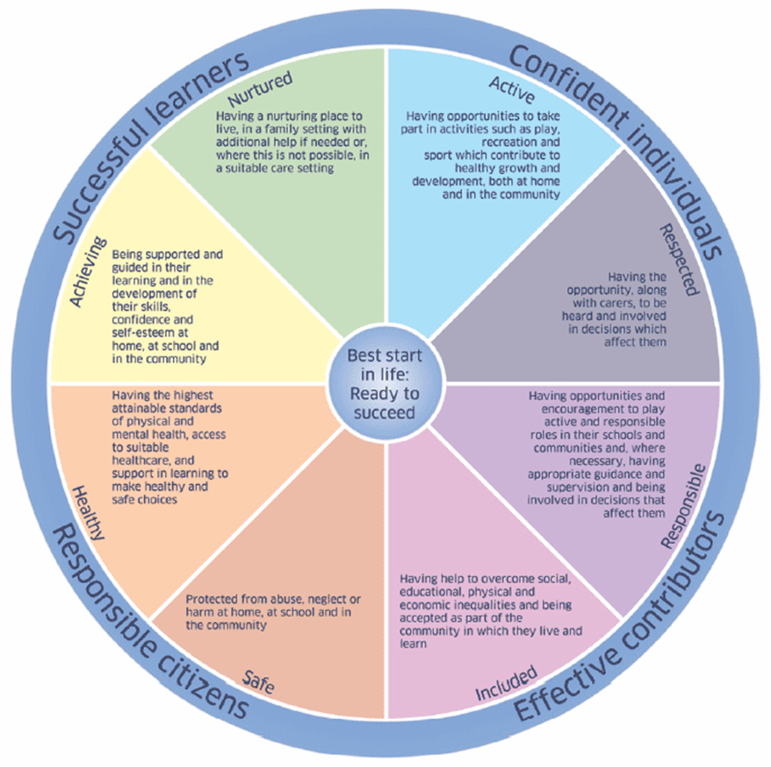
The statements of experiences and outcomes in health and wellbeing reflect a holistic approach to promoting the health and wellbeing of all children and young people. They are consistent with the United Nations Convention on the Rights of the Child, which sets out the right for all children and young people to have access to appropriate health services and to have their health and wellbeing promoted.

