
Dundee City Disability Sport
Discovery Games 2025
Sporting Opportunities for Motor Activities
(SOMA)
Tuesday 16th September 2025 – 10.30am – 2.30pm
Regional Performance Centre
Mains Loan, Dundee, DD4 9BX
Closing Date for Entries Friday 22 August 2025


Dundee City Disability Sport, in partnership with Leisure and Culture Dundee and supported by Scottish Disability Sport are delighted to invite entries from across Scotland to Discovery Games SOMA event at Dundee’s Regional Performance Centre.
This is the third year that SOMA has been included within Discovery Games and we are delighted to see its return.
The Regional Performance Centre is an excellent facility for this type of event as the building is fully accessible. There is good parking, low level entrance, changing places toilet and access directly to the sportshall
A tour of the facility can be found using the link below.
https://www.accessable.co.uk/dundee-city-council/access-guides/regional-performance-centre-for-sport-rpc-dundee

What is SOMA?
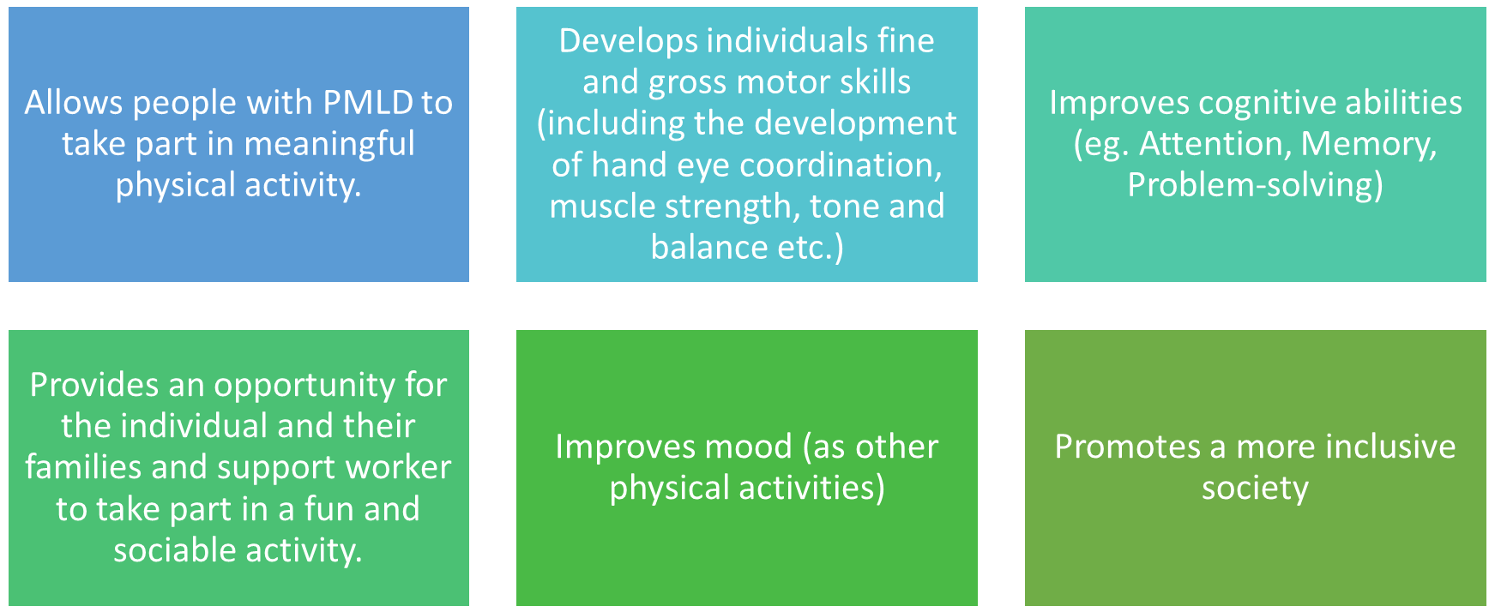

The word SOMA comes from the Greek meaning “Body” and also stand for Sporting Opportunities for Motor Activities.
Sporting Opportunities for Motor Activities (SOMA) is a physical activity methodology especially devised for people with profound and multiple learning disabilities (PMLD).
It has been designed to allow people with a physical and learning disabilities to take part in meaningful, fun and safe physical activities focusing on motor skills.
SOMA sessions use a number of specially designed activity stations aiming to develop motor skills while providing a suitable and stimulating activity for people with PMLD.
SOMA is very much a person-centred activity.
Each activity station is designed to focus on one or multiple motor skills
Each activity can also be modified to suit individual’s needs
During each SOMA activity the aim is to -
Perform a task/skill.
Perform the task/skill consistently.
Develop and enhance task/skills being performed.
Fees:
Fees of £5.00 per player per event. All cheques should be made payable to Dundee City Disability Sport.
Complete the entry form below and email it to: darren.thomson@leisureandculturedundee.com or by post to:
Darren Thomson
Leisure and Culture Dundee
Level 3, Central Library
The Wellgate
Dundee
DD1 1DB
Discovery Games 2025 SOMA Registration Form
Club Name: __________________ Contact Name: ________________
Contact email: _________________
Please indicate if you are happy to be included in any photos taken for partner social media platforms (end column)
Player Name | Email Address | Home Postcode | Date of Birth | Gender | Disability (LD, PD, WC, SS) | Any additional info we need to be aware of | Photo consent
Example  Joe Bloggs | Joe.bloggs@bowling.com | ABC 123 | 01/01/2001 | M | LD |  | YES

