Bowls Scotland
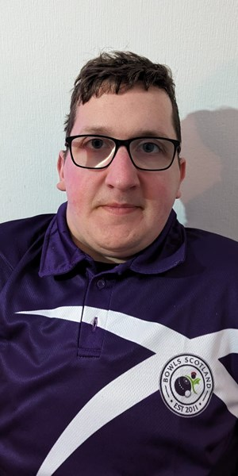
Who are you?
Stuart Chesby, Disability Development Officer at Bowls Scotland.

Why are you attending the Scottish Disability Sport National Exhibition Event?

Having attended several Para Sports Festivals hosted by regional SDS branches over the past year, I have witnessed first-hand the benefits of a person-centered approach. This approach allows individuals with a disability to experience sports in a welcoming and inclusive environment that emphasises ability rather than disability. It provides opportunities for everyone, regardless of their disability, to participate and enjoy sports. Therefore, when the opportunity to attend the SDS National Exhibition arose, we were very eager to be involved!

Why should people come and chat to you?
We look forward to attending the National Exhibition to highlight the sport's inclusivity and challenge the stigma that it [bowls] is only for older people. Our aim is to change the narrative and show that bowls is a sport for all ages. With various adaptations, individuals with a wide range of disabilities and impairments can participate. We will also highlight the help and support available from Disability Development Officer, Stuart Chesby, and the wider Bowls Scotland team. At the event, we will showcase a wide range of aids and adaptations, so pop by and Try Bowls!

What are the benefits of getting active?
As someone with a disability, I know that sports are great for both physical and mental health. They help reduce stress, anxiety, and improve overall mood. Plus, being active is a fantastic way to meet new people and feel connected, reducing social isolation. It also boosts self-esteem and confidence, showing that our disabilities don't define our potential.

Why should people attend the SDS National Exhibition Event?
The event offers a fantastic opportunity to try new sports, including bowls! It's also a great chance to meet new people and discover opportunities you might not have been aware of or considered. Whether you're looking for a new hobby to socialise more or seeking competitive opportunities, this event promises to be a fantastic day. You'll get to try a wide range of sports; all while surrounded by knowledgeable people who are keen to offer support. We look forward to seeing you on Saturday 14 June in Stirling!

