Muscular Dystrophy UK
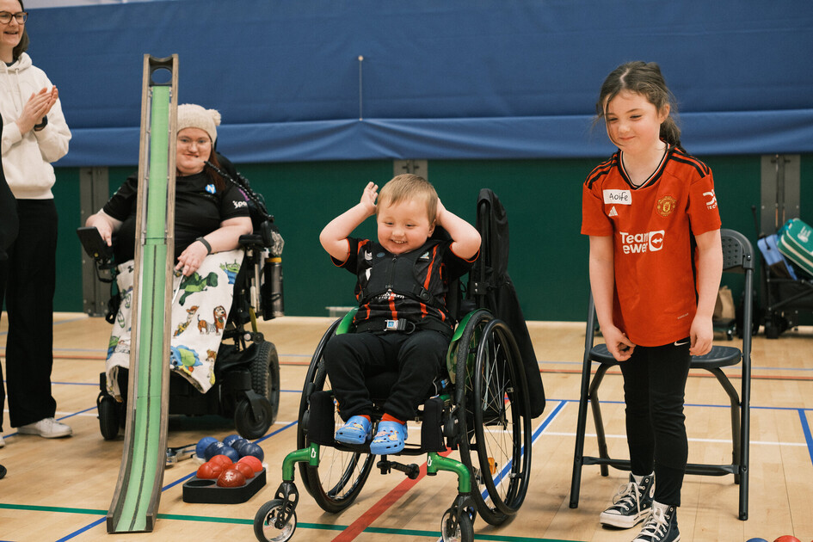
Muscular Dystrophy UK are the leading charity for more than 110,000 people living with one of over 60 muscle wasting and weakening conditions. We provide expert support and information, fund vital research into treatments, and campaign for better access to specialist care. We’re excited to attend Scottish Disability Sport’s first-ever National Exhibition. We're looking forward to connecting with people from across Scotland and showcasing the ways we support individuals living with muscle-wasting and weakening conditions, and their families.

At Muscular Dystrophy UK, we know that staying active can have a positive impact on both physical and mental wellbeing. Inclusive sports can also offer valuable peer support - building confidence, friendships, and a strong sense of community. The SDS National Exhibition is a fantastic opportunity to discover inclusive sporting opportunities, connect with others, and learn how to stay active safely and confidently. We are proud to be part of this event, promoting awareness and support for individuals and families living with muscle wasting and weakening conditions.
We look forward to strengthening our collaborative work with Scottish Disability Sport to enhance opportunities for those we support.

