

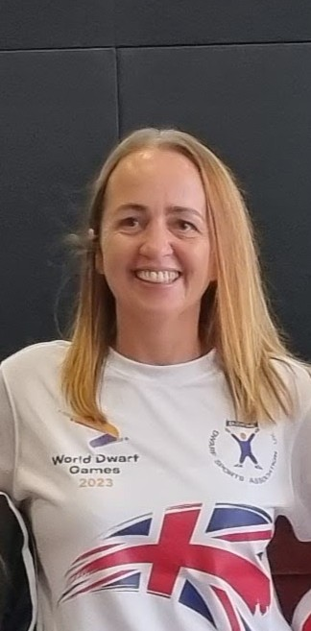
Hi everyone! My name is Hailey Davidson, and I'm the Chairperson of the Dwarf Sports Association UK (DSAuk), and also the Scotland Regional Coordinator.
The DSAuk is a national charity with a clear goal: to help people with dwarfism across the UK live healthy and active lives. We do this through our 10 regions, the Scotland's region started in 2015. Our monthly events bring our community together from all over the country, helping us build connections and get involved, fostering a sense of belonging and encouraging active participation.
I'm really excited that DSAuk will be part of the Scottish Disability Sport National Exhibition event! Since our region got started, SDS has been instrumental in supporting us to build the network we have now in Scotland.
Alongside attending to support this fantastic event; we're also eager to explore new joint ventures, activities, and partnerships with other organisations. Helping to offer our members even more diverse opportunities, and crucially, to raise awareness so that every person with dwarfism in Scotland knows that DSAuk exists and is here to support them.
Come say hello at our stand – we can't wait to meet you!

