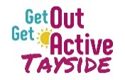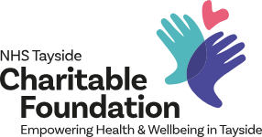

Scottish Disability Sport
Get Out Get Active Tayside Programme Administrator
Salary: £24,000 Hours: 37.5 hours per week
Are you a dynamic and enthusiastic team player who has a passion for inclusion?
Scottish Disability Sport (SDS), in partnership with NHS Tayside and the Tayside Charitable Foundation is seeking to appoint a Get Out Get Active (GOGA) Tayside Programme Administrator to support disabled and non-disabled people to take part in fun and inclusive physical activity across Tayside.
The post holder will work in partnership with local partners to develop and deliver physical activity opportunities.
The successful candidate will have understanding and experience of administrative processes and procedures as well as being organised, IT literate and self-motivated with excellent communication, prioritisation and time management skills. Experience and knowledge of marketing, communications, website management and social media will also be required.
This post will be Dundee office/home based and will be line managed by the GOGA Tayside Programme Manager. Full time, part-time and flexible hours options will be considered for discussion with the successful candidate. SDS will also consider employment or secondment arrangements with agreement from current employer.
For a full job description, candidate specification and application form, see our website: www.scottishdisabilitysport.com or apply online using the links below:

- Application Form
- Job Description
- Equality Monitoring Form

If you would like more information on the post, please contact Iona McKay, GOGA Programe Manager on 07971 641208, or at iona.mckay@nhs.scot.

Closing date: 9am on Friday 22 November 2024

Interviews: Friday 29 November 2024 (Time TBC)

Scottish Disability Sport is an equal opportunities employer, and our recruitment, selection and assessment process is based entirely on values, skills and competencies required of the specific roles.

