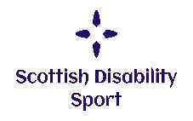
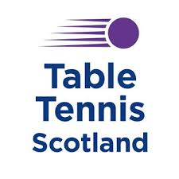
Table Tennis for People with a Disability in Scotland
This fact sheet provides an overview of table tennis for people with a disability in Scotland. It also provides useful contact details to signpost you to your local club to develop your skills and start to play, volunteer or coach people with a disability in table tennis.

The Development of Table Tennis
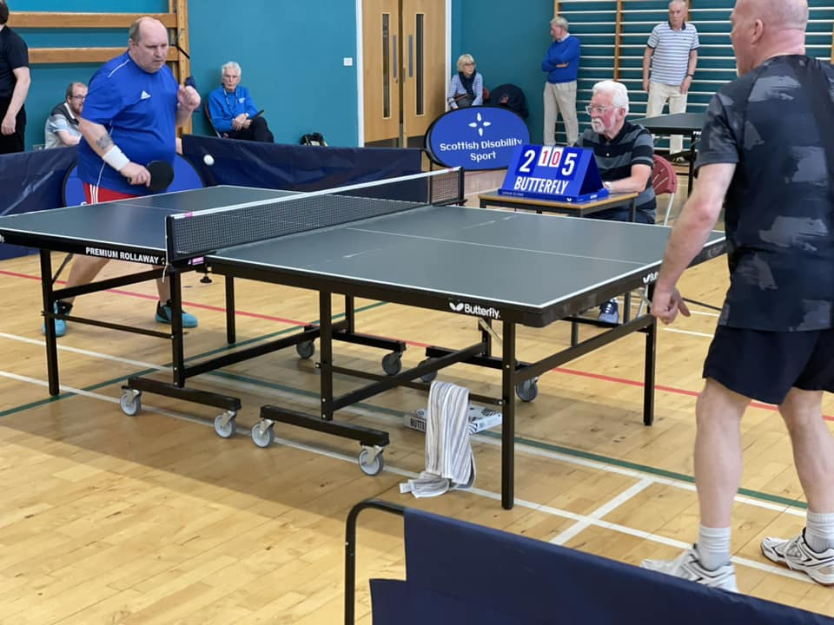
Table Tennis Scotland, previously the Scottish Table Tennis Association, was established in 1935. Our mission is “to foster and promote table tennis to attract more players, achieve higher standards and improve the profile of the sport”.
Table tennis was included in the first Paralympic Games in Rome in 1960 and is now practised by athletes in more than 100 different countries.
Athletes from all physical impairment groups, are allowed to compete in standing or sitting classes. Players with a learning disability can also compete. We aim to provide opportunities for anyone with a disability who wants to take part in table tennis.
On top of this Parkinsons only competitions and training have grown massively in recent years. This is following studies of the benefits table tennis potentially has for those living with Parkinson's.
Men and women can compete in individual, doubles or team events, and matches consist of five sets of 11 points each. In Para table tennis the rules are the same as for the non-disabled game with the following exceptions:
- In doubles play wheelchair users may hit the ball consecutively;
- When serving to a player in a wheelchair the service must, if it were to continue on its path, cross the end line at the receiver’s end of the table;
- A disabled player may place a hand on the surface of the table during a rally after playing a shot in order to recover their position.
Polybat is an adapted form of table tennis that was originally devised with the aim of not only helping disabled people to play a form of table tennis but also to support any player with poor hand/eye/ball co-ordination. The game is played on a conventional table tennis table with side panels and no net. The players use a paddle-like bat and a plastic airflow ball with the aim of hitting the past your opponent along the surface of the table with no bounce. Scoring is the same as table tennis.
Table Tennis Scotland’s strategic plan 2023-2027 is fully inclusive and has a clear vision on the pathway for para table tennis. Currently we are working on providing a stronger pathway from the introduction to the sport to competing at the Paralympics.

The Classifications
The object of this classification system is to group together those players who have a movement potential which is approximately equal.
Each individual class consists of players who have relatively similar abilities for performing basic table tennis techniques. This means that players with different types of impairments, and in various parts of the body, may reside in a single class, if their functional potential for beginning (service) and continuing a rally is nearly comparable.
There are currently 11 classes in Para Table Tennis
- Classes 1 to 5 for wheelchair players (sitting table tennis)
- Classes 6 to 10 for standing players
(standing table tennis)
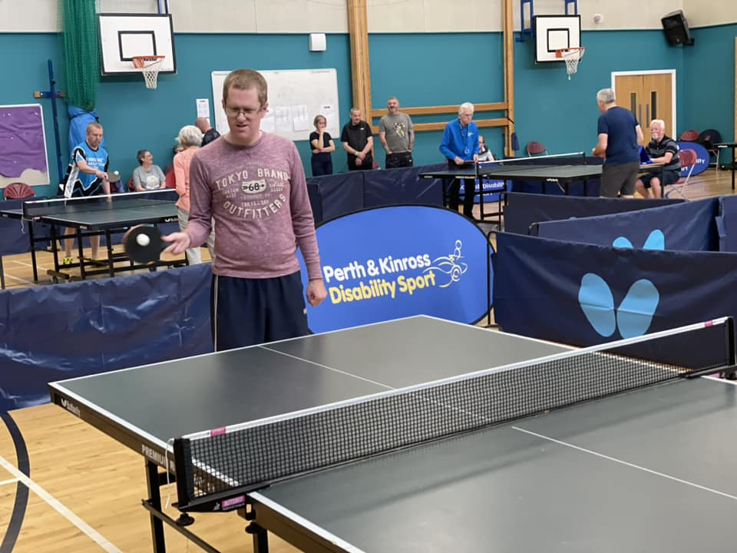
- Class 11 for players with a learning disability

Coach Education
Introduction to Inclusive Practice: This entry-level module is designed for everyone but will be particularly useful to those who are new to inclusive coaching, would like to become inclusive coaches, or would like to gain confidence in coaching inclusively.

Online Disability Awareness Training: Our online ‘Disability Awareness Training’ will provide you with the information to support you to feel more confident working with disabled table tennis players by making your sessions more accessible, showing you ways of communicating with players whilst meeting individual needs. Everything is table tennis specific and includes sections on coaching, classification, competitions and communication aimed at clubs and leagues.

TTS Workshops: Once a year Table Tennis Scotland run workshops alongside camps or tournaments to bring coaches together and help raise awareness of best practices.

Useful Resource
Inclusive Club E-Learning Resource: This resource is designed for mainstream clubs and activity providers to further their knowledge of creating a welcoming and inclusive club environment and culture for participants with disabilities. It supports and promotes inclusive practice by providing clubs with information, tools, and resources to offer opportunities to participants with disabilities.

Leading Performers
Martin Perry, from Paisley, picked up table tennis in 2011. Martin is a Class 6 athlete and is currently ranked 7 in the world (as of 2024). Martin is currently part of the GB Para Performance Squad. He qualified for his first ever Paralympic Games in Paris 2024.
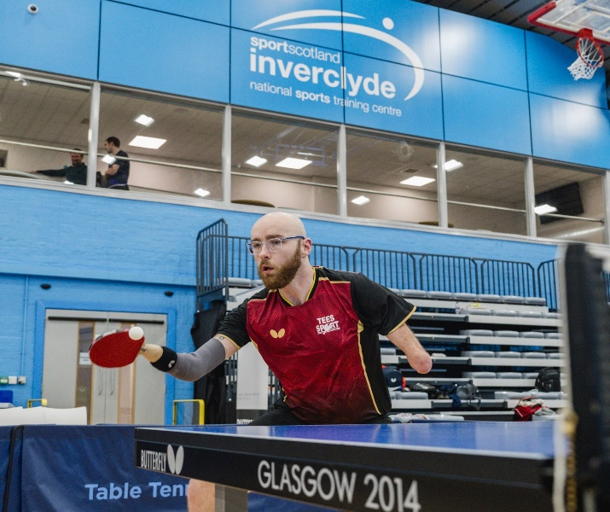

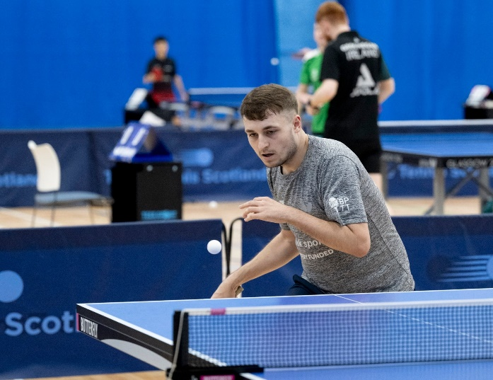
Ryan Henry, from North Ayrshire, is a class 8 athlete and is part of the GB Para Pathway squad. Ryan has competed for over 10 years now and is a great talent for Scottish table tennis. Ryan is currently ranked 36 in the world (as of 2024).

Competitions
- Perth & Kinross Disability Sport Table Tennis Championship – held annually
- West of Scotland Disability Sport Table Tennis Championship – First event this season
- British Para Table Tennis Grand Prix Circuit – Different locations throughout the year
- Paralympic Games – held every four years just after the Olympic Games in the same venue
- World Championships – held every four years
- ITTF Para Tour – for elite players, system similar to ITTF World Tour

Key Contacts
Table Tennis Scotland
Caledonia House
South Gyle
Edinburgh EH12 9DQ
T: 0131 317 8077
E: info@tabletennisscotland.co.uk

Key Websites
Table Tennis Scotland www.tabletennisscotland.com
British Para Table Tennis https://www.britishparatabletennis.com/
International Table Tennis Federation www.ittf.com
Scottish Disability Sport www.scottishdisabilitysport.com
Dwarf Sports Association www.dsauk.org
Special Olympics
www.specialolympicsgb.org.uk
Sports Coach UK www.sportscoachuk.org

