Para Swimming
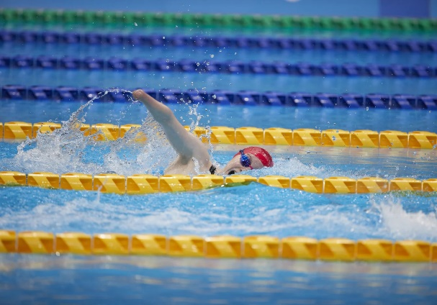
Toni Shaw
Classification: S9/SB9/SM9
Date of Birth: 05/08/2003
From: Aberdeen
Club: University of Stirling
Coach: Patrick Miley
Facebook: Toni Shaw
Instagram: tonishaw_
Twitter: @tonishaw_

Making her Paralympic debut at Tokyo 2020, Toni Shaw showed plenty of promise with three fourth-placed finishes and an incredible bronze medal over her favoured distance in the 400m freestyle S9 final.

Shaw has been swimming since age eight and held 14 Scottish records by age 14.
The Aberdeen athlete went on to win World gold in the 400m freestyle S9 at the 2022 World Championships in Madeira, as well as bronze in the 100m butterfly S9, before securing another long-distance bronze one year later at the Manchester 2023 edition.

Shaw was introduced to the elite programme in 2018, where she made her international debut at Dublin’s European championships.

Six medals - two of each colour - were again the result and a world record in the Women’s 34pt 4x100m Medley Relay. Her European titles came in that relay and the 400m freestyle S9 with silvers in the 100m Butterfly S9 and 200m Individual Medley SM9 and bronze across the 100m Freestyle S9 and 100m Backstroke S9 categories.

Another six medals followed at her first World Championships in London, where she was part of the two gold-winning Medley and 34-point relay teams, along with a pair of silvers and bronzes in her individual events.

Major Results
Tokyo 2020 Paralympic Games
- 100m freestyle S9: 4th
- 100m butterfly S9: 4th
- 400m freestyle S9: Bronze
- 4x100m medley relay (34pts): 4th

Manchester 2023 World Para Swimming Championships
- 400m freestyle S9: Bronze

Madeira 2022 World Para Swimming Championships
- 400m freestyle S9: Gold
- 100m butterfly S9: Bronze

London 2019 World Para Swimming Championships
- 100m butterfly S9: Silver
- 100m freestyle S9: Bronze
- 200m individual medley S9: Bronze
- 400m freestyle S9: Silver
- 4x100m medley relay (34pts): Gold
- 4x100m freestyle relay (34pts): Gold

