Samantha Kinghorn MBE

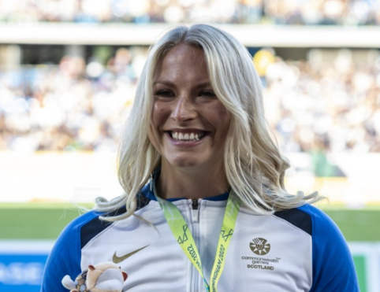
Date of birth: 6 January 1996
Home town: Scottish Borders
Occupation: Full time athlete
Sport: Athletics
Events: 100m, 400m, 800m and 1500m
Classification: T53
Club: Red Star Athletic
Coach: Rodger Harkins
Instagram/Twitter: sammikinghorn/@Sam_Kinghorn

Background
Samantha got involved in the sport after an accident left her paralysed in 2010. She tried wheelchair racing for the first time while still in hospital. She travelled to Stoke Mandeville to compete in the spinal unit games in April 2011 and fell in love with the sport. Samantha competed her first competition in 2012 in the London mini marathon, coming second, and did a few other low key events that year. Then in 2013 she started regularly competing around the UK and internationally.
Sporting Highlights
2023 – World Para Championships – 100m gold, 400m silver, 800m silver.
2021 - Paralympic Games – 100m bronze, 400m silver, 800m 4th.
2019 - World Para Championships – 100m bronze.
2018 - Commonwealth Games – 1500m 4th, Marathon 4th.
2017 - World Para Championships – 100m gold, 200m gold (WR), 400m bronze, 800m 5th.
2016 - Paralympics – 100m 5th, 400m finalist, 800m 6th (ER).
2015 - World Para Championships – 100m 5th, 200m bronze, 400m 6th, 800m 7th.
2014 - European Para Championships – 100m gold, 400m gold, 800m gold.
2014 - Commonwealth Games – 1500m 5th place.
Honours
Samantha was appointed Member of the Order of the British Empire (MBE) in the 2022 Birthday Honours for services to disability sport.

