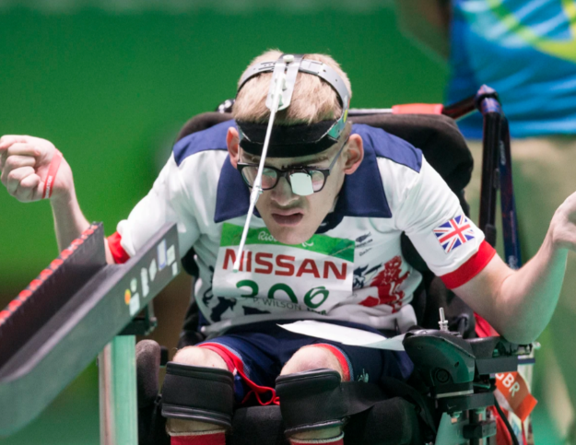
Patrick Wilson

Credit: ParalympicsGB

Sport: Boccia

Region: Edinburgh

Date of Birth: 08/10/1995

Classification: BC3 (competition partner Meredith Greenwood)

Instagram: @patrickw262
X: @PatrickR_Wilson
Patrick first got into boccia through a regional come-and-try multi-sport event. As a 15 year old, it took a while for Patrick to get into the game but after realising he was pretty good at the sport he joined a club in Edinburgh, where he started to get to grips with the intricacies of the game and gain a greater tactical understanding of the sport.
After weekly training sessions, Patrick’s coach suggested he enter a competition and Patrick went on to win gold at the Scottish Championships. With his competitive interest spiked, Patrick has progressed to international competition, winning silver in the BC3 pairs at the 2014 World Championships and beating the World number 2 in competition at the World Open earlier this year.
Patrick made his ParalympicsGB debut at Rio, helping the BC3 Pair finish sixth.

At the European Championships, the BC3 Pair of Patrick, Jamie McCowan and Scott McCowan claimed the silver medal in 2017 and bronze in 2019.
He has also represented Britain at the 2022 World Championships in Rio de Janiero, and latterly reached the last 16 where he was beaten by British team-mate Will Arnott. He was also part of the GB squad that competed at the European Para Championships in Rotterdam in 2023.
Patrick saw a return to winning ways in 2023, securing silver at the Fortaleza World Cup.
In the first half of 2024, Patrick won bronze at the Sao Paulo World Cup and gold at the Lahti Challenger.

Major Results

2024 Sao Paulo World Cup – Bronze.

2024 Lahti Challenger – Gold.

2023 Fortaleza World Cup – Silver.

2017 BISFed European Championships, held in Povoa de Varzim, Portugal.
BC3 Pair: Silver

- 2014 BISFed Boccia World Championships, Beijing, China
BC3 Pair: Silver

