Martin Perry – Table Tennis

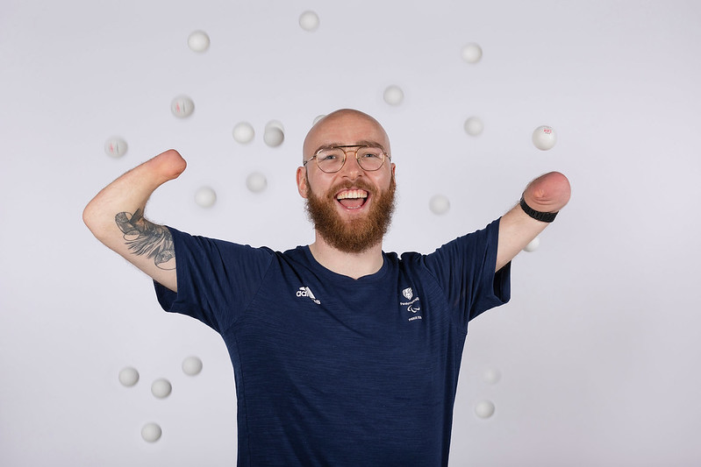

Classification: Class 6 Singles, Class 14 Doubles
Date of Birth: 08/05/1994
From: Dumbarton, Scotland
Instagram: @perry94
X: @martinTTperry

The youngest of four brothers, Martin has always been a keen sportsman despite being born without either forearm or the bottom part of his left leg. He played basketball, football, rugby and hockey before finding a knack for table tennis at a Scottish Disability Sport summer camp.
Martin started 2024 by taking silver in the US Open and secured qualification for his first Paralympic Games in Paris with further singles medals in Italy, Spain and Poland.
He narrowly missed qualification for Tokyo 2020 where he had set up a crowdfunding page to help his journey to many tournaments, but the run to Japan was ended in a hard-fought five-set quarter-final in the last qualifying tournament.
Martin entered the 2022 World Championships as a wildcard and made the most of the opportunity by taking bronze in the Class 6 singles - his first major singles achievement, which saw him become a top-10 ranked player for the first time.
The Dumbarton man consolidated that result with another great performance at the European Championships in Sheffield in 2023, taking bronze in the men’s class 6 singles as well as bronze in the men’s class 14 doubles with Aaron McKibbin.
Martin had further cause for celebration last December when his wife Siobhain gave birth to their daughter Beira.

