Para Swimming

Faye Rogers
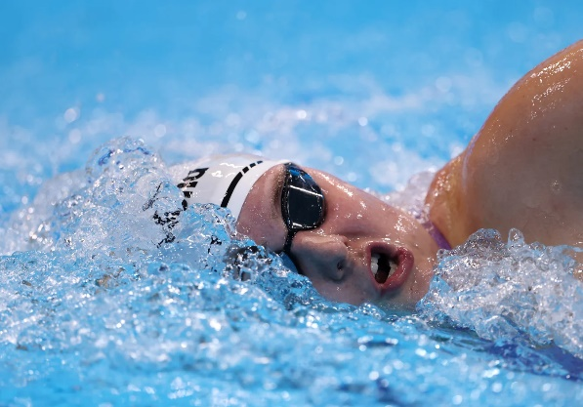
Classification: S10/SB10/SM10
Date of Birth: 21/09/2002
From: Stockton on Tees
Club: University of Aberdeen
Coach: Patrick Miley
Facebook: Faye Rogers
Instagram: fayerogersx

Faye Rogers is a World champion Para swimmer and European record holder in the Women’s S10 100m Butterfly.

At her international debut meet, Rogers registered bronze in both the 400m Freestyle and 200m Individual Medley alongside her Butterfly gold at the Manchester 2023 World Para Swimming Championships.

At the 2024 Aquatics GB Swimming Championships, she won multi-classification bronze in the 100m Butterfly to secure a nomination time for a maiden Paralympic Games appearance in Paris.

The Patrick Miley-coached swimmer previously competed at the 2021 Olympic Selection trials, however at 19-years-old she was involved in a car accident which resulted in a fused elbow. Returning to the sport she loved, Rogers transitioned to Para swimming competition after being told about the option to get classified.

Away from the pool Faye is an aspiring doctor and is currently completing a biochemistry degree at the University of Aberdeen.

She enjoys cooking and baking, with her favourite thing to make being Mexican food or sticky toffee pudding.

