
'Right on Target'
Forth Valley Boccia Club

Dear All

Forth Valley 'Right on Target' Boccia Club would like to extend a warm invitation to clubs, squads and individuals to enter the clubs open Boccia Championships on Saturday 2nd June 2018.

Please see attached details and entry form, if you wish further information do not hesitate to contact Jean Duncan, Head Coach on 07970 153 103 or email – jeanmd50@gmail.com.

I look forward to seeing you on Saturday 2nd June 2018.

Yours Sincerely
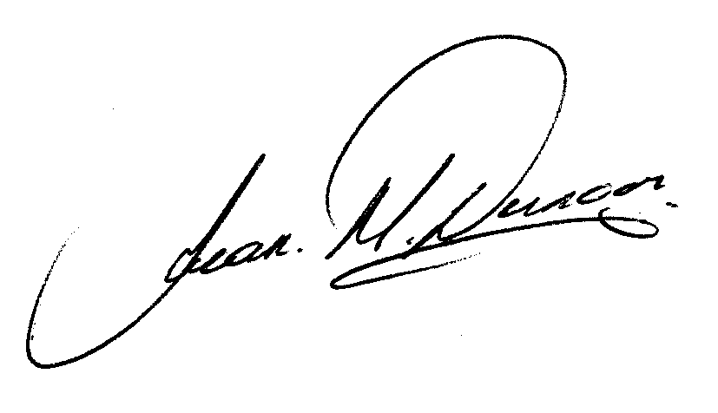
Jean M Duncan
Right on Target Boccia Club

Right on Target Open Boccia Club Championships
Saturday 2nd June 2018

Please see entry form on page 4. Details of the event are as follows:

Venue: The Peak

Date: Stirling Sports Village,
Forthside, Stirling, FK8 1QZ

Time: 10.00 am to 4.30 pm (registration 9.30am)

Catering: There are catering facilities at the venue though individuals can bring along their own packed lunches and drinks.

Entry Free: £5.00 per entry (Cheques to be made payable to Right on Target Boccia Club)

Closing Date Entries should be returned no later than Friday 25th May 2018 (entries after this date will not be accepted)

Entries: Return to Jean Duncan, C/O Forth Valley Disability Sport, Central Sporting Partnership Office, Gannochy Sports Centre, University of Stirling, Stirling, FK9 4LA

Right on Target Open Boccia Club Championships
Saturday 2nd June 2018

Entries are invited from the following classes:

BISFed Classes

- BC1
- BC2
- BC3
- BC4

Non- BISFed Classes
- Players with a physical disability who may not classify for the above classes
- Players with a learning disability.

Age Groups; -

- 10 – 15 years Junior Competition

- 16 years + Senior Competition

All players will play as individuals.

Players will play in a round robin group in their own class and age group where possible however, this may change depending in the number of entrants in each class. Medals will be awarded to 1st, 2nd and 3rd place in each class.
Games will be played under BISFed Rules.

If you require further information please contact Jean Duncan on 07970 153 103 or email jeanmd50@gmail.com

Please note no further information will be circulated prior to the competition. If as a result of unforeseen circumstances the event is cancelled entrants will be informed.

Right on Target Open Boccia Club Championships

Saturday 2nd June 2018

Entry Form

Individual/Squad/Club: __________________________________________________________

Contact Person: _________________________________________________________________

Address: _______________________________________________________________________

________________________________________________________________________________

Telephone: _________________________ Email: _______________________________

Name | Individual/ Squad/Club | Class | Age Group
Example1 John Smith | Right on Target Boccia Club | BC1 | Junior
Example 2 Jeanie Bloggs | Right On Target Boccia Club | Non BISFED Learning Disability | Senior
Example 3 John Brown | Individual | Non BISfed Physical Disability | Junior

Number of players = ____ @ £5.00 player, total enclosed = £ ____. Please make cheques payable to Right on Target Boccia Club. Closing Date for Entries is Friday 25th May 2018. Entries received after this date will not be accepted. Entries should be returned to: Jean Duncan C/O Forth Valley Disability Sport, Central Sporting Partnership Office, Gannochy Sports Centre, University of Stirling, Stirling, FK9 4LA or email - jeanmd50@gmail.com

